Project Report on

STABLER

*Submission to THE ROBOTICS CLUB - SNIST as a part of INDUCTION'22*

TEAM NO - 9



THE ROBOTICS CLUB-SNIST

# SREENIDHI INSTITUTE OF SCIENCE AND TECHNOLOGY

## (AUTONOMOUS)

(Affiliated to JNTU University, Hyderabad)

Yamnampet, Ghatkesar, Hyderabad – 501301.

2022

### CERTIFICATE

This is the project work titled ‘Project name’ byNikitha, Varun, K.Rasagna,M.Yaseen Nawaz, M.Ankitha, B.vivek under the mentorship of Poojith Kumar, M.Shashank and is a record of the project work carried out by them during the year 2021-2022 as part of INDUCTION under the guidance and supervision of

**Mr. BHUVAN PRATAP AGARWAL**

**&**

**Mr. S. V. REDDY**

**Technical head**

**Mr. Md. NIHAL ASJAD**

**The President of**

**THE ROBOTICS CLUB**

**Dr. A. PURUSHOTHAM**

**Faculty Advisor**

**Mechanical Department**

**DECLARATION**

The project work reported in the present thesis titled **“STABLER”** is a record work done by Team 09 in **THE ROBOTICS CLUB** as a part of **INDUCTION-2022.**

**No part of the thesis is copied from books/ journals/ Internet and wherever the portion is taken, the same has been duly referred in the text. The report is based on the project work done entirely by TEAM 09 and not copied from any other source.**

ACKNOWLEDGMENT

This project report is the outcome of the efforts of many people who have driven our passion to explore into implementation of **STABLER.** We have received great guidance, encouragement and support from them and have learned a lot because of their willingness to share their knowledge and experience.

Primarily, we would like to express our gratitude to our mentors,Poojith Kumar,M.Shashank. Their guidance has been of immense help in surmounting various hurdles along the of our goal.

We thank our technical heads **‘Mr. BHUVAN PRATAP AGARWAL and Mr. S. V. REDDY’** for being with us till the end of the project completion.

We thank all the members of Steering **Steering Body**, **Executive Body, Technical Advisory Board, Club's** **Incubation and Competence Committee** of **The Robotics Club** for helping us with crucialparts of the project. We are deeply indebted to **Mr. Md. NIHAL ASJAD -** The President, **Mr. KARUMURI JAYANTH SIVA MADHAV -** The Vice President and **Mr. Gelli Kusal Venkata Sai Shravanth** - SAB Chairman and **Ms. RUSHIKA REDDY** - General Secretary **THE ROBOTICS CLUB** respectively and also every other person who spared their valuable time without any hesitation whenever we wanted.

We also thank our faculty advisor **Dr. A. Purushotham**, Professor, Mechanical Department, who encouraged us during this project by rendering his help when needed.

Contents Pg. No

|  |  |  |
| --- | --- | --- |
| Chapter1 | Introduction: |  |
| 1.1 | Problem Statement |  |
| 1.2 | Introduction of the project |  |
| 1.3 | Literature survey |  |
| 1.4 | Organization of project |  |

|  |  |  |
| --- | --- | --- |
| Chapter2 | Architecture: |  |
| 2.1 | List of figures |  |
| 2.2 | Components used |  |
| 2.3 | Hardware |  |
| 2.4 | Software |  |

|  |  |  |
| --- | --- | --- |
| Chapter3 | Implementation and working: |  |
| 3.1 | Block diagram |  |
| 3.2 | Circuit diagram |  |
| 3.3 | Working |  |
| 3.4 | Flowchart |  |

|  |  |  |
| --- | --- | --- |
| Chapter4 | Experimental Results and Conclusions: |  |
| 4.1 | Results |  |
| 4.2 | Future enhancements |  |
| 4.3 | Conclusions |  |
| 4.4 | References |  |
| 4.5 | Source code |  |
| 4.6 | List of expenses |  |

**1.INTRODUCTION:**

Despite having spacious parking arenas in the basement of most of the malls make the cars wait at the entrance for collecting money or to issue the parking tokens adding to the peak hour traffic.this leads to a jam in parking lots.so we found a solution through a bot which can help to slove this problem.

**I.PROBLEM STATEMENT:**

In our daily life we are seeing a lot of traffic in parking areas,drive-in’s,pubs,many malls in these areas many cars and other vehicles are rushed and a less area will be allotted for these and a lot of time is wasted for many people.

**II.INTRODUCTION OF THE PROJECT:**

This smart parking system project consists of Arduino, five IR sensor , one servo motor, and one LCD display. Where the Arduino is the main microcontroller that controls the whole system. Two IR sensors are used at the entry and exit gates to detect vehicle entry and exit in the parking area. And other three IR sensors are used to detect the parking slot availability. The servo motor is placed at the entry and exit gate that is used to open and close the gates. Also, an LCD display  is placed at the entrance, which is used to show the availability of parking slots in the parking area.When a vehicle arrives at the gate of the parking area, the display continuously shows the number of empty slots. If there have any empty slots then the system opens the entry gate by the servo motor. After entering the car into the parking area, when it will occupy a slot, then the display shows this slot is full. If there is no empty parking slot then the system displays all slots are full and does not open the gate.

**III.LITERATURE SURVEY:**

Advancements in computing and electronics have redefined healthcare. Monitoring, medical imaging and observation have become computerized, reducing human effort and removing the possibility of human error.Medical procedures involving complex machinery which required professionals at all times to be used have been replaced by smaller, more accessible models which can be used by anyone. For example, oximetry is now a simple process that can be carried out by the patient  
themselves. The development of more compact microprocessors, chips and sensors is the most imperative part of this. This has lead to the evolution of basic forms of self-operating healthcare devices. Automated saline systems and dialysis apparatus are an example of this. In course of time, many more autonomous devices can be used to ensure the best possible care is provided for patients.

**2.ARCHITECTURE :**

**I.COMPONENT:**

a) **Arduino Uno:**

The Arduino UNO is an open-source microcontroller board based on the Microchip ATmega328P microcontroller and developed by Arduino.cc. The board is equipped with sets of digital and analog input/output (I/O) pins. The. board has 14 digital I/O pins (six capable of PWM output), 6 analog I/O pins, and is programmable with the Arduino IDE (Integrated Development Environment)

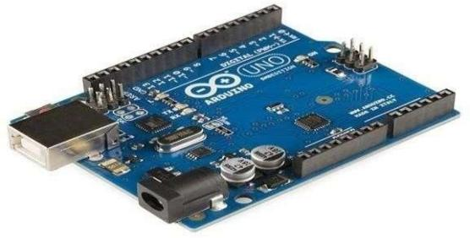

**b)Servo motor:**

A servomotor (or servo motor) is a rotary actuator or linear actuator that allows for precise control of angular or linear position, velocity and acceleration. It consists of a suitable motor coupled to a sensor for position feedback. It also requires a relatively sophisticated controller, often a dedicated module designed specifically for use with servomotors 

**c) LCD 16x2 Display:**

A liquid-crystal display (LCD) is a flat panel display, electronic visual display, or video display that uses the light modulating properties of liquid crystals. ... 16x2 means that 16 characters can be displayed in each of the 2 rows of the 16x2 LCD, thus a total of 80 characters can be displayed at any instance of time.

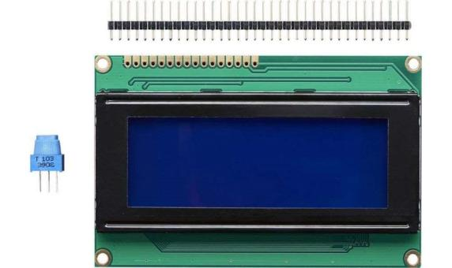

**d) Jumper Wires:**

Jumper wires typically come in three versions: maleto-male, male-to-female and female-to-female. The difference between each is in the end point of the wire. Male ends have a pin protruding and can plug into things, while female ends do not and are used to plug things into. Male-to-male jumper wires are the most common and what you likely will use most often. When connecting two ports on a breadboard, a maleto-male wire is what you’ll need. Alligator clips, which consist of two spring metal clips connected by wire, are actually just fancy jumper wires! Their unique connection point (they can be clipped on instead of inserted into) allow alligator clips to be used in a variety of situations that would get a little awkward with a traditional jumper wire. One of the most common uses for alligator clips in education is with the Makey Makey, though they can also be used to connect the ports on a Lilypad board as well as for a number of other applications.

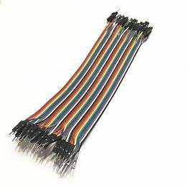

**e) Bread Board:**

Breadboards have many tiny sockets (called 'holes') arranged on a 0.1" grid. The leads of most components can be pushed straight into the holes. ICs are inserted across the central gap with their notch or dot to the left. Wire links can be made with single-core plastic-coated wire of 0.6mm diameter (the standard size), this is known as 1/0.6mm wire. I suggest buying a pack with several colors to help identify connections, red for +Vs wires, black for 0V, and so on. Stranded wire is not suitable because it will crumple when pushed into a hole and it may damage the board if strands break off.

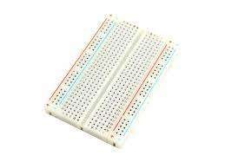

**II.HARDWARE:**

**a) Drill machine:**

Drill press, also called Drilling machine, device for producing holes in hard substances. The drill is held in a rotating spindle and is fed into the workpiece, which is usually clamped in a vise resting on a table. The drill may be gripped in a chuck with three jaws that move radially in unison, or it may have a tapered shank that fits into a tapered hole in the spindle. Means are always provided for varying the spindle speed and on some machines for automatically feeding the drill into the workpiece.

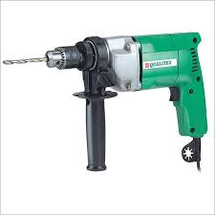

**b) Sawing machine:**

sawing machine, **device for cutting up bars of material or for cutting out shapes in plates of raw material**. The cutting tools of sawing machines may be thin metallic disks with teeth on their edges, thin metal blades or flexible bands with teeth on one edge, or thin grinding wheels.

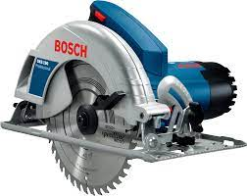

**c) Soldering iron:**

A soldering iron is a hand tool used to heat solder, usually from an electrical supply at high temperatures above the melting point of the metal alloy. This allows for the solder to flow between the workpieces needing to be joined.

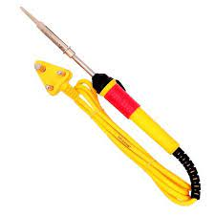

**d) Wooden chassis:**

Chassis is the vehicle’s main support structure, also known as the ‘Frame.’ It bears all the stresses on the vehicle in both static and dynamic conditions. In a vehicle, it is analogous to the skeleton of a living organism. The origin of the word Chassis lies in the French language. Whether it is a two-wheeler or a car, or a truck, every vehicle has a chassis-frame. However, its form, obviously, varies with the vehicle type

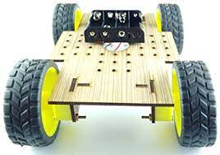

**III.SOFTWARE REQUIRED:**

**a) ARDUINO IDE**:   
Arduino Integrated Development Environment is an open- source application software created by Arduino. It is used to write and upload code on to the Arduino boards. It supports C and C++ programming languages, and has a built-in compiler.

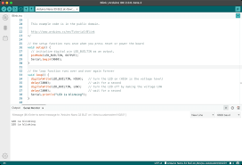

**b) Fusion 360:**

Fusion 360 is a computer-aided designing (CAD) soft-ware application for 3-D modelling and simulation. It’s other functions include computer-aided manufacturing (CAM) and  
computer-aided engineering (CAE), as well as designing printed circuit boards.

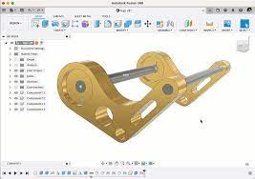  
 **c) Fritzing**  
Fritzing is an open-source electronic design automation (EDA) software to design electronics hardware, printed circuit boards and schematic circuit diagrams. It is an offshoot of the Processing programming language and the Arduino microcontroller.

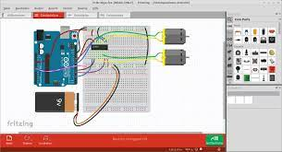

**IV.Implementation and working:**

**a)Block diagram:**

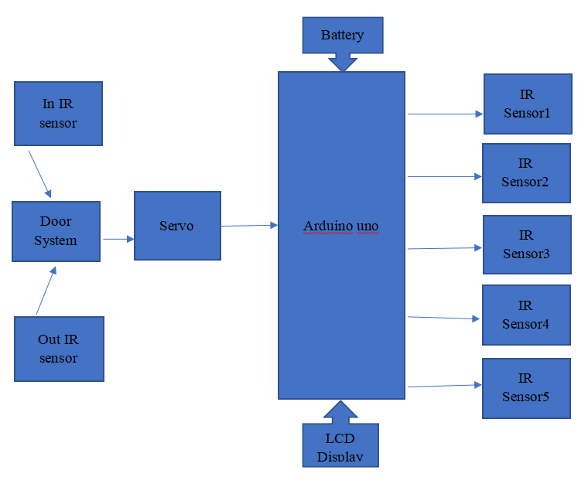

**b) Circuit diagram:**

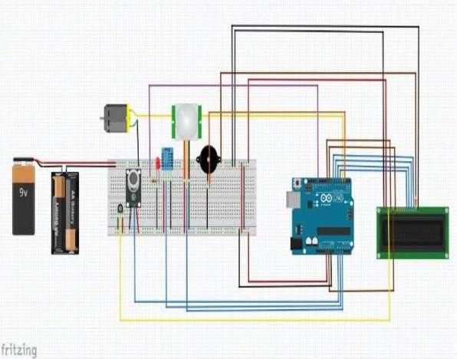

**c)Working:**

After assembling all components according to the circuit diagram and uploading the code to the Arduino board. Now place the sensors and servo motor at accurate positions.There are four parking slots in this project, IR-sensor -3, 4, 5, and 6 are placed at slot-1, 2, 3, and 4 respectively. IR sensor-1 and 2 are placed at the entry and exit gate respectively and a servo motor is used to operate the common single entry and exit gate. The LCD display is placed near the entry gate. The system used IR sensor-3, 4, 5, and 6 to detect whether the parking slot is empty or not and IR sensor-1, and 2 for detecting vehicles arriving or not at the gate.In the beginning, when all parking slots are empty, then the LCD display shows all slots are empty.When a vehicle arrives at the gate of the parking area then the IR sensor-1 detects the vehicle and the system allowed to enter that vehicle by opening the servo barrier. After entering into the parking area when that vehicle occupies a slot then the LED display shows that the slot is full. In this way, this system automatically allows 4 vehicles. In case the parking is full, the system blocked the entrance gate by closing the servo barrier. And the LED display shows that slot-1, 2, 3, and 4 all are full.When a vehicle leaves a slot and arrives at the gate of the parking area then the IR sensor-2 detects that vehicle and the system open the servo barrier. Then the LCD display shows that the slot is empty. Again the system will allow entering a new vehicle.

**d) Flowchart:**



**IV. Experimental Results and Conclusions:**

**a) Results:**

we are seeing a lot of traffic in parking areas,drive in’s,pubs,many malls in these areas many cars and other vehicles are rushed and a less area will be allotted for parking and a lot of time is wasted for many people.Our bot is helpful to prevent jams in parking areas.it gives a person clear idea about where to place his vehicle.

**b)Future Enhancement:**

we can provide security to the vehicles in the absence of user thus if any theft happen we can inform to user

**c) Conclusions:** .

Our bot is helpful to prevent jams in parking areas.it gives a person clear idea about where to place his vehicle.

**d)References:**

* **<https://www.arduino.cc/>**
* **<https://www.youtube.com/>**
* **<https://www.tinkercad.com/>**
* **https://www.wikipedia.org/**

**SOURCE CODE:**

#include <Adafruit_LiquidCrystal.h>

#include <Servo.h> //includes the servo library

#include <Wire.h>

#include <LiquidCrystal_I2C.h>

LiquidCrystal_I2C lcd(0x27, 16, 2);

Servo myservo;

#define ir_enter 10

#define ir_back 9

#define ir_car1 6

#define ir_car2 7

#define ir_car3 8

int S1=0, S2=0, S3=0;

int slot = 3;

void setup(){

Serial.begin(9600);

pinMode(ir_car1, INPUT);

pinMode(ir_car2, INPUT);

pinMode(ir_car3, INPUT);

pinMode(ir_enter, INPUT);

pinMode(ir_back, INPUT);

myservo.attach(3);

myservo.write(0);

lcd.setCursor (0,0);

lcd.print("TRC");

lcd.setCursor (0,0);

lcd.print("HIHIH");

delay(2000);

Serial.println("car parking");

lcd.setCursor (0,1);

lcd.print(" System ");

delay (2000);

lcd.clear();

Read_Sensor();

lcd.begin();

int total = S1+S2+S3;

slot = slot-total;

}

void loop(){

Read_Sensor();

if(digitalRead(ir_enter) == 0){

myservo.write(90);

Serial.println("car parking if block");

delay(2000);

}

else{

myservo.write(0);

delay(2000);

}

if(digitalRead(ir_back) == 0){

myservo.write(90);

delay(2000);

}

else{

myservo.write(0);

delay(2000);

}

lcd.setCursor (0,0);

if(S1==1){lcd.print("S1:fill");}

else{lcd.print("S2:Emp");

Serial.println("s2 emp");

}

lcd.setCursor (8,0);

if(S2==1)

{

lcd.print("S2:Fill ");

}

else

{

lcd.print("S2:Emp");

}

lcd.setCursor (0,1);

if(S3==1)

{

lcd.print("S3:Fill ");

}

else

{

lcd.print("S3:Emp");

}

}

void Read_Sensor(){

S1=0, S2=0, S3=0;

if(digitalRead(ir_car1) == 0){S1=1;}

if(digitalRead(ir_car2) == 0){S2=1;}

if(digitalRead(ir_car3) == 0){S3=1;}